KUBERNETES TASK
Task Description:
Setup minikube at your local and explore creating namespaces (Go through official documentation).
O/P:
- Launch an EC2 instance:
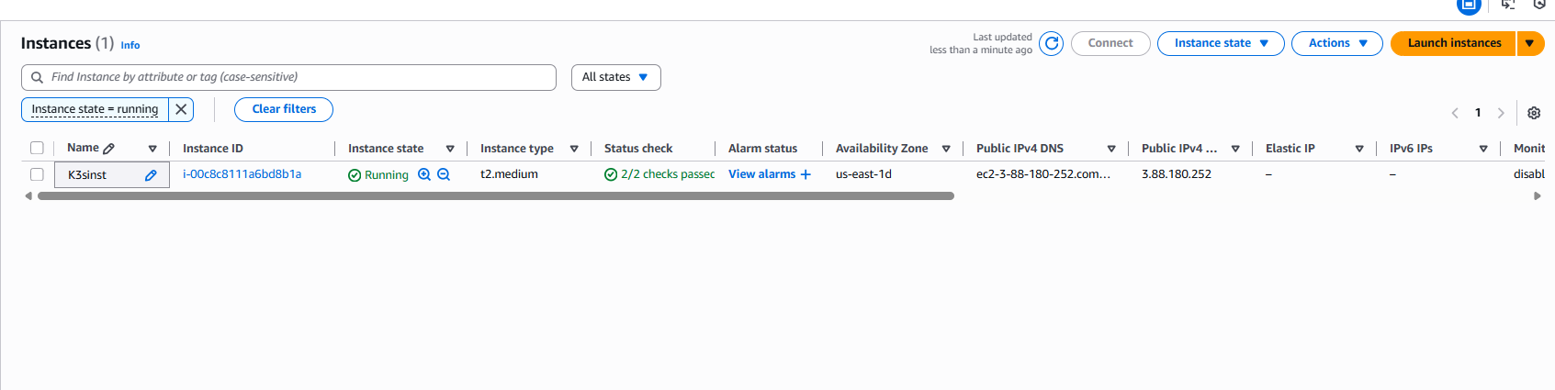
- Install Docker:
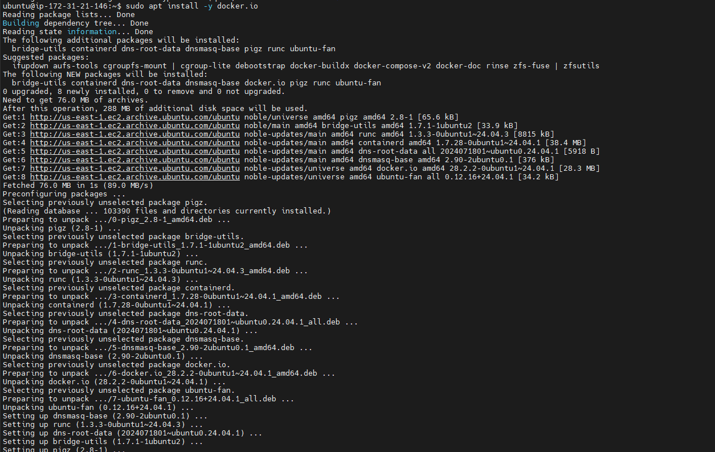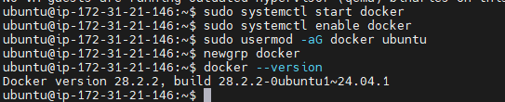
- Install kubectl:
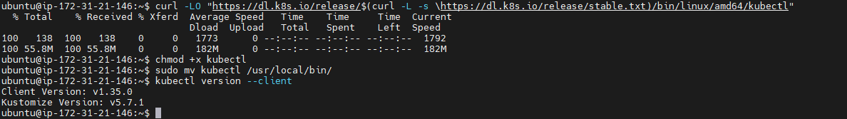
- Install Minikube:
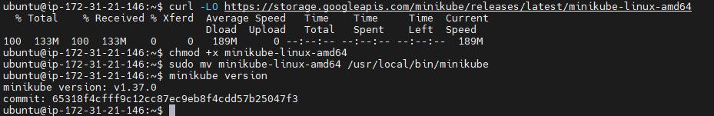
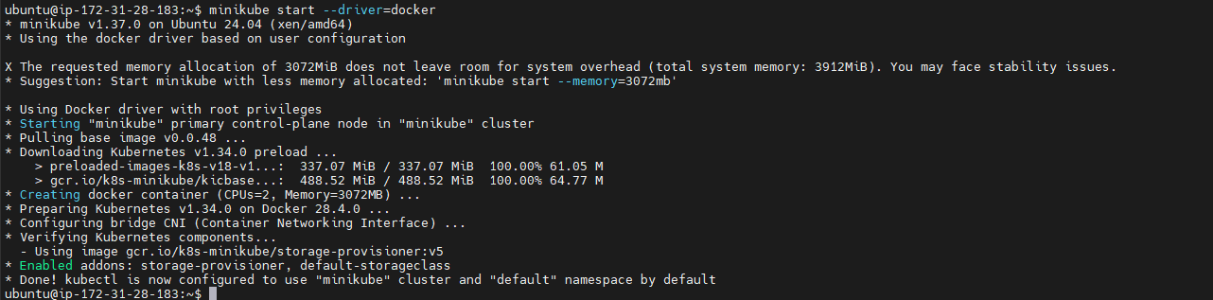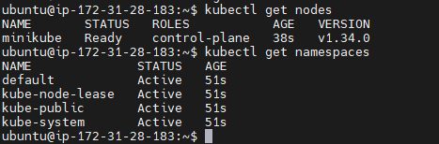
- Create a New Namespace:
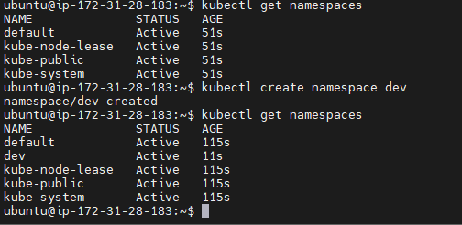
- Deploy Application into Namespace:
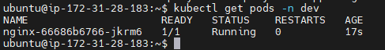
- Delete Namespace:

